Week 4 – 27/01/2025 to 30/01/2025

Git and GitHub
Day 1: Concepts and Importance of Git
Topics Covered:
- What is Git?
Git is a tool that helps you manage changes to your code over time. It keeps track of every little change or update you make, you can always look back at previous versions or undo mistakes if needed.

- Why Git?
- Distributed System: Every developer has a complete local copy of the project, allowing for offline work and increased resilience.
- Performance: Git is fast and efficient, handling large projects with ease.
- Branching and Merging: Git's lightweight branching and easy merging facilitate parallel development and feature isolation.
- Collaboration: Tools like GitHub enhance team collaboration, code reviews, and project management.
- Track Changes: Git tracks changes and maintains a history, making it easy to revert to previous versions.

Compare to other Tools
1. Git vs. Subversion (SVN)
- Architecture: SVN is centralized, meaning it relies on a single central repository. Git’s distributed architecture provides greater flexibility and resilience.
- Branching and Merging: Git’s branching and merging capabilities are far superior to SVN, offering more options and easier conflict resolution.
- Performance: Git generally outperforms SVN, especially in large projects, due to its efficient storage and local operations.
2. Git vs. Mercurial
- Ease of Use: Mercurial is often considered easier for beginners, with a simpler command set and a more consistent user experience. However, Git’s extensive community and resources level the playing field.
- Performance: Both Git and Mercurial are distributed and offer similar performance, but Git’s branching and merging features give it an edge in flexibility.
- Community and Ecosystem: Git’s larger community and richer ecosystem make it the preferred choice for many teams, offering more integrations and third-party tools.
3. Git vs. Perforce
- Scalability: Perforce is known for handling very large codebases with ease, making it popular in industries like gaming and embedded systems. Git, while also scalable, can struggle with extremely large binary files unless optimized with tools like Git LFS (Large File Storage).
- Branching and Merging: Git’s branching and merging model is more flexible and user-friendly compared to Perforce, making it better suited for teams that require frequent branching and merging.
- Cost: Git is open-source and free, whereas Perforce requires a commercial license, which can be a significant factor for many teams.

Disadvantages of Git
- Learning Curve: Git can be complex to learn, especially for beginners.
- Complex Commands: Some commands and operations can be difficult to understand and remember.
- Merge Conflicts: Resolving conflicts when merging branches can be challenging.
- Storage: The local repository can take up significant space on your computer.
- Setup and Configuration: Initial setup and configuration can be time-consuming.
- Not Ideal for Large Binary Files: Git is less efficient at handling large binary files (e.g., videos, images).

- Git Workflow
- Clone Repository: git clone git@github.com:username/repository.git
- Create Branch: git checkout -b feature-branch-name
- Check Status: git status
- Stage Changes: git add filename or git add .
- Commit Changes: git commit -m "Add feature X"
- Push Branch: git push origin feature-branch-name
- Create Pull Request: On Github/other service
- Update Local Repository: git checkout main, git pull origin main
- Delete Branch: git branch -d feature-branch-name, git push origin --delete feature-branch-name

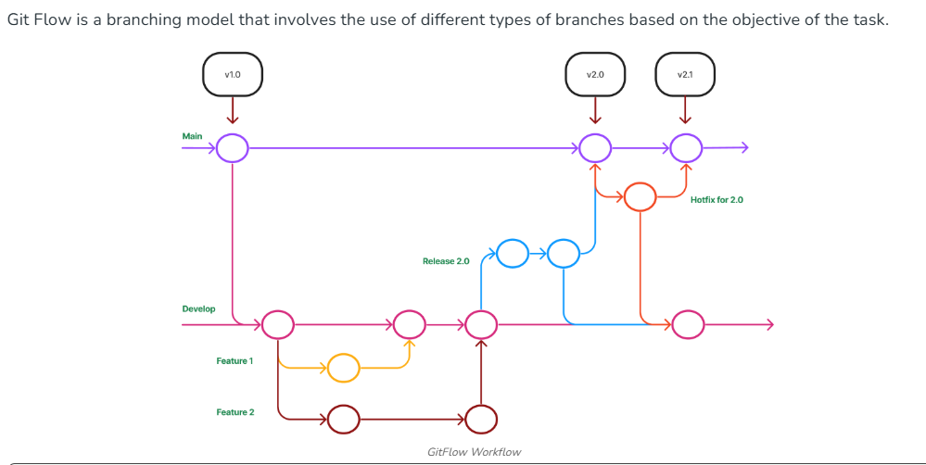

- Branching Strategies in Git
  - GitFlow Workflow
GitFlow enables parallel development, allowing developers to work separately on feature branches. A feature branch is created from a master branch, and after completion of changes the feature branch is merged with the master branch.
The types of branches that are present in GitFlow for different purposes:
- Master: Used for product release
- Develop: Used for ongoing development
- Feature Branches: Created from the develop branch to work on specific features.
- Release Branches: Created from the develop branch to prepare for production releases and bug fixes
- Hotfix Branches: Created from the master branch to address urgent issues directly in production. It helps in addressing discovered bugs smoothly, allowing developers to continue their work on the develop branch while the issue is resolved.
The Master and Develop branches are the main branches that remain throughout the journey of the software. The other branches are supporting branches and are short-lived that serving specific purposes.
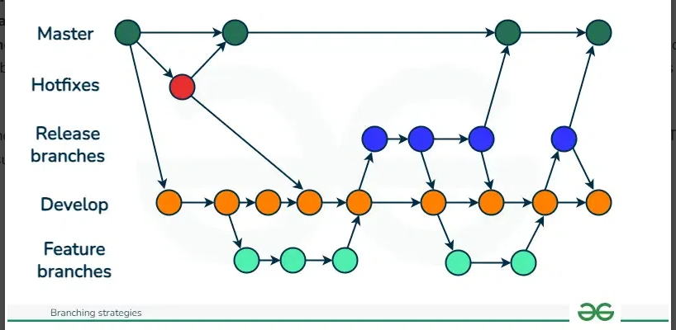

Pros of GitFlow
- Enables parallel development while keeping the production branch stable.
- Organizes work effectively with branches for different purposes.
- Ideal for managing multiple versions of production code.
- GitFlow streamlines the release management process.
- Ensures smooth merging of new features into the main codebase, reducing conflicts.
- GitFlow provides a clear process for handling bugs and releasing hotfixes quickly to production.

Cons of GitFlow
- Complexity increases as more branches are added, potentially leading to difficulties in management.
- Multi-step merges increase the risk of errors and merge conflicts.
- Debugging issues becomes challenging due to the extensive commit history.

  - Trunk-Based Development(TBD)
Trunk-based development (TBD) is a branching strategy in which all developers make changes directly on the main branch, commonly referred to as the trunk, which holds the project's deployable code.
- Development happens on one primary branch (usually main or master) without long-lived branches.
- Feature flags are used to hide incomplete features until they are ready.
- Encourages small, frequent commits to reduce merge conflicts.
- Supports continuous integration and continuous delivery (CI/CD).
- Best suited for small teams or projects that prefer a simple and fast workflow.
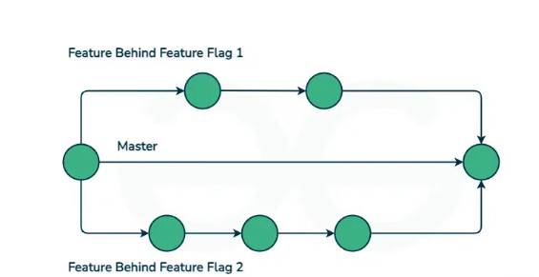

Pros of Trunk Based Development
- Developers gain better visibility into each other’s changes because commits are made directly to the trunk.
- Frequent small commits improve collaboration and transparency across the team.
- There is a lower chance of encountering merge conflicts since long-lived branches are avoided.
- The trunk remains continuously releasable due to regular integration.
- Continuous integration supports faster, safer, and more stable releases.
Cons of Trunk Based Development
- Needs clear communication to ensure proper feature isolation.
- Requires strong developer discipline to avoid conflicts.
- Difficult to manage with large teams.
- Maintaining backward compatibility with older releases can be challenging.

30/01/2026

Task 1: Passwordless Connection between servers
Server.txt File – Contains all the different Server
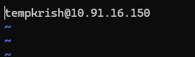

Shell Script for Connection to all the Servers
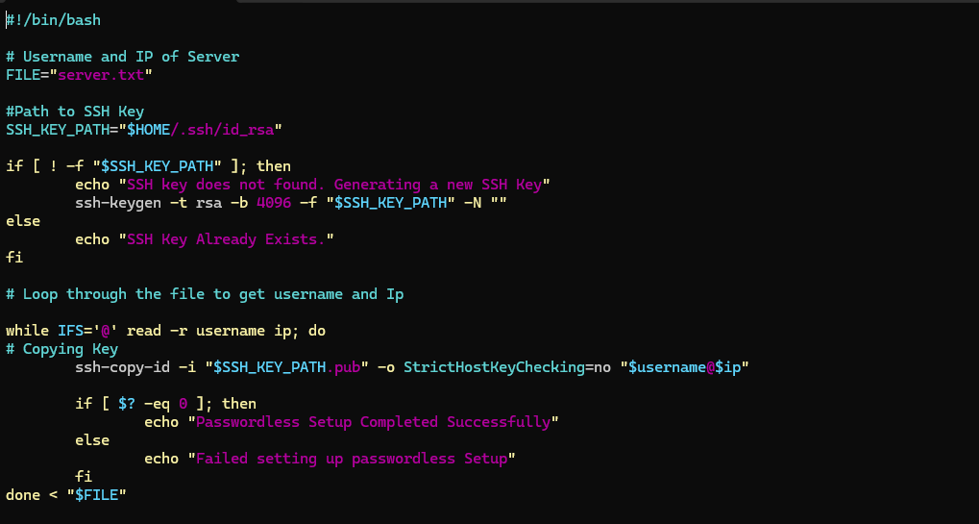
Output
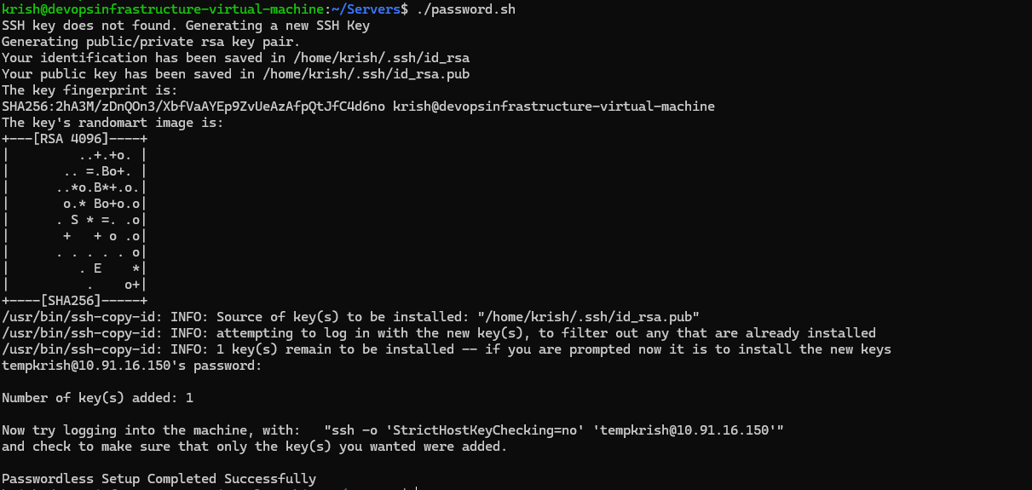

Tempkrish.ssh File
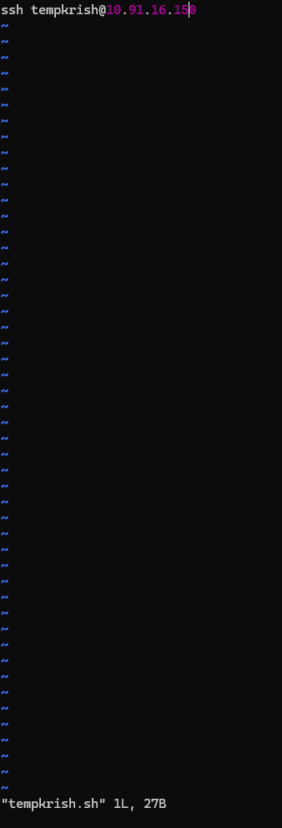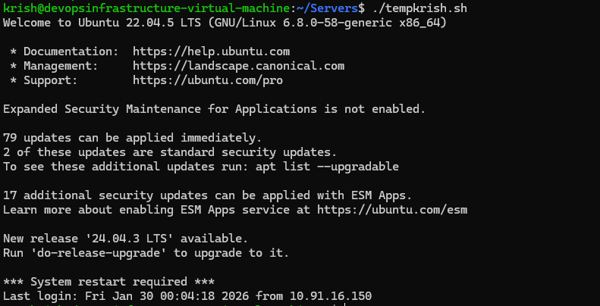

Task 2 : Password less Login to your VM

On Windows Powershell run the following command
  - ssh-keygen -t rsa -b 4096 -N “”
  - cat ~/.ssh/id_rsa.pub Copy it’s output
  - Login to your VM
  - mkdir -p ~/.ssh
  - chmod 700 ~/.ssh
  - echo "<PASTE_YOUR_PUBLIC_KEY_HERE>" >> ~/.ssh/authorized_keys
  - chmod 600 ~/.ssh/authorized_keys
Now Logout of VM Server and try login using ssh user@ip.

